CSV and Json Format:

CSV which is format of excel..this postman reads the values from excel and runs via run collection in postman.

Creation:

Click on three dots of Github-API.

Click on run collection.

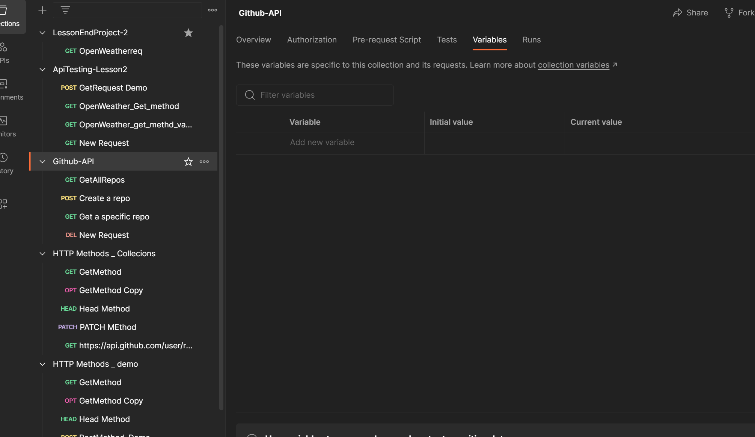

We get run ordr of selecting the request of Collection.

Select the file of excel from local machine. To run the scripts.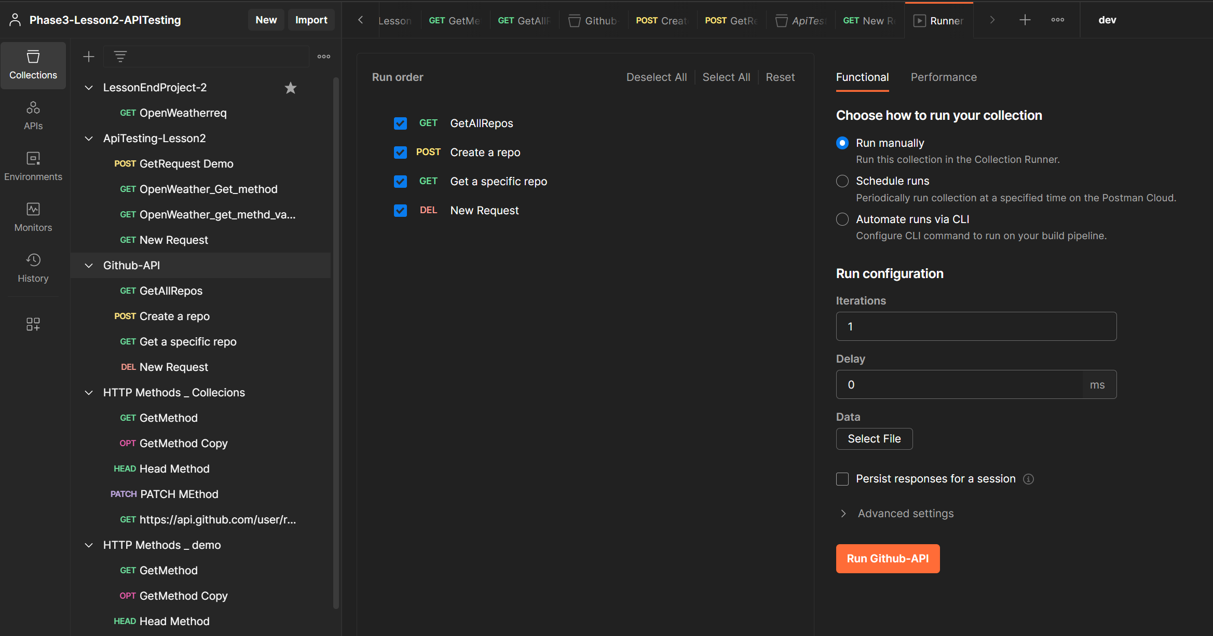

Excel Needed to be created and fetched to run collection.

Click on Run Github-API Collection.

Now all Requests of GitHUb-API runs.

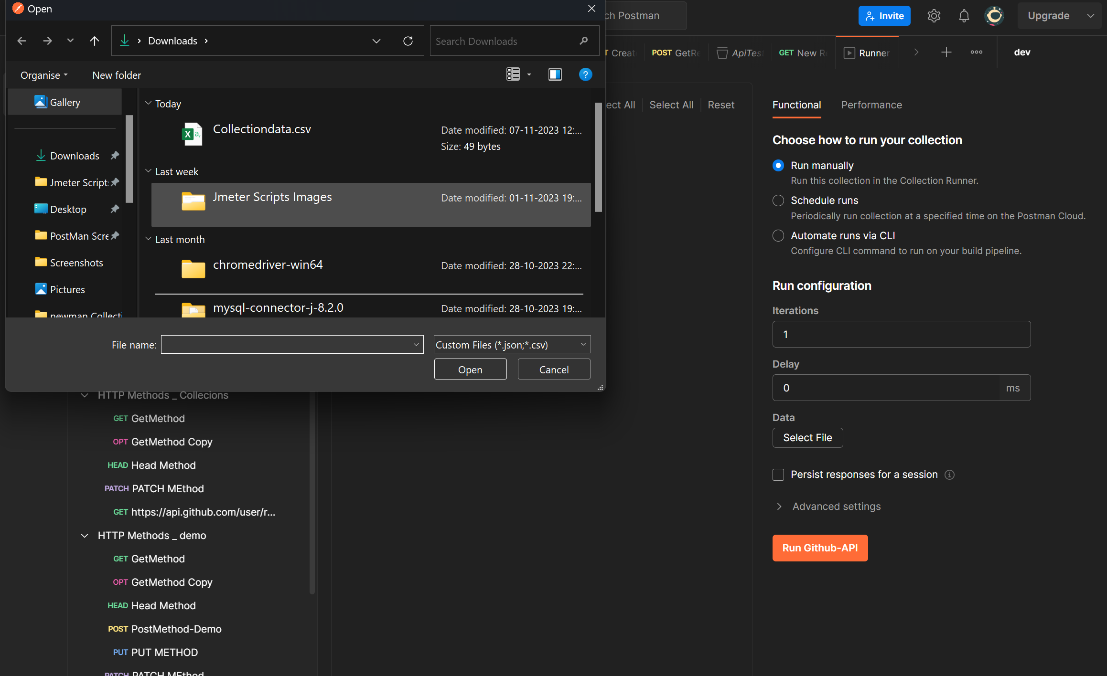

OUTPUT: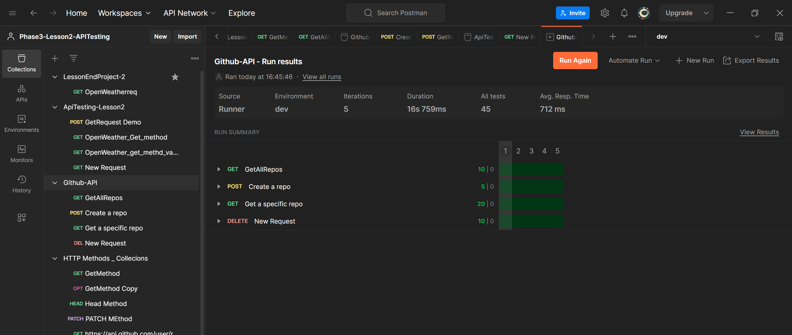

JSON Format

JSON Format Gives the script output in Java script object Notation. It looks like below image.

